1,design a login page.

Program code

*<?***xml version="1.0" encoding="utf-8"***?>*

<**android.support.constraint.ConstraintLayout xmlns:android="http://schemas.android.com/apk/res/android"**

**xmlns:app="http://schemas.android.com/apk/res-auto"**

**xmlns:tools="http://schemas.android.com/tools"**

**android:layout_width="match_parent"**

**android:layout_height="match_parent"**

**tools:context=".MainActivity"**>

<**LinearLayout**

**android:layout_width="match_parent"**

**android:layout_height="match_parent" android:orientation="vertical"**>

<**EditText**

**android:id="@+id/editText"**

**android:layout_width="wrap_content"**

**android:layout_height="wrap_content"**

**android:ems="10"**

**android:inputType="textPersonName"**

**android:text="USERNAME"**

**android:textColor="@color/colorAccent"**

**tools:layout_editor_absoluteX="85dp"**

**tools:layout_editor_absoluteY="54dp"** />

<**EditText**

**android:id="@+id/editText2"**

**android:layout_width="wrap_content"**

**android:layout_height="wrap_content"**

**android:ems="10"**

**android:inputType="textPersonName"**

**android:text="PASSWORD"**

**android:textColor="@color/colorAccent"**

**tools:layout_editor_absoluteX="85dp"**

**tools:layout_editor_absoluteY="175dp"** />

<**Button**

**android:id="@+id/button"**

**android:layout_width="120dp"**

**android:layout_height="wrap_content"**

**android:background="@color/colorPrimary"**

**android:text="LOGIN"**

**android:textSize="30sp"**

**tools:layout_editor_absoluteX="148dp"**

**tools:layout_editor_absoluteY="303dp"** />

</**LinearLayout**>

</**android.support.constraint.ConstraintLayout**>

Design

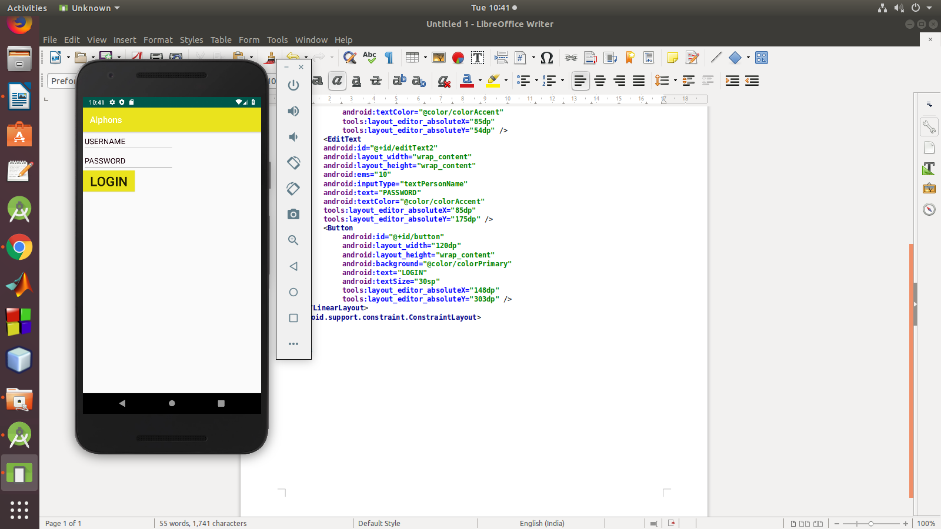

2,change the content in the text view on a button click

program

<**LinearLayout**

**android:layout_width="match_parent"**

**android:layout_height="match_parent"**

**android:orientation="vertical"**

**android:gravity="center"**

**xmlns:android="http://schemas.android.com/apk/res/android"**>

<**TextView**

**android:id="@+id/tv"**

**android:layout_width="wrap_content"**

**android:layout_height="wrap_content"**

**android:text="change button"**/>

<**Button**

**android:id="@+id/btn1"**

**android:layout_width="wrap_content"**

**android:layout_height="wrap_content"**

**android:text="Change"**

**android:onClick="change"**/>

</**LinearLayout**>

JAVA

**package** com.example.sjcet.p2;

**import** android.support.v7.app.AppCompatActivity;

**import** android.os.Bundle;

**import** android.view.View;

**import** android.widget.TextView;

**public class** MainActivity **extends** AppCompatActivity {

TextView **tv**;

@Override

**protected void** onCreate(Bundle savedInstanceState) {

**super**.onCreate(savedInstanceState);

setContentView(R.layout.***activity_main***);

**tv** = findViewById(R.id.***tv***);

}

**public void** change(View view) {

**tv**.setText(**"Essa"**);

}

}

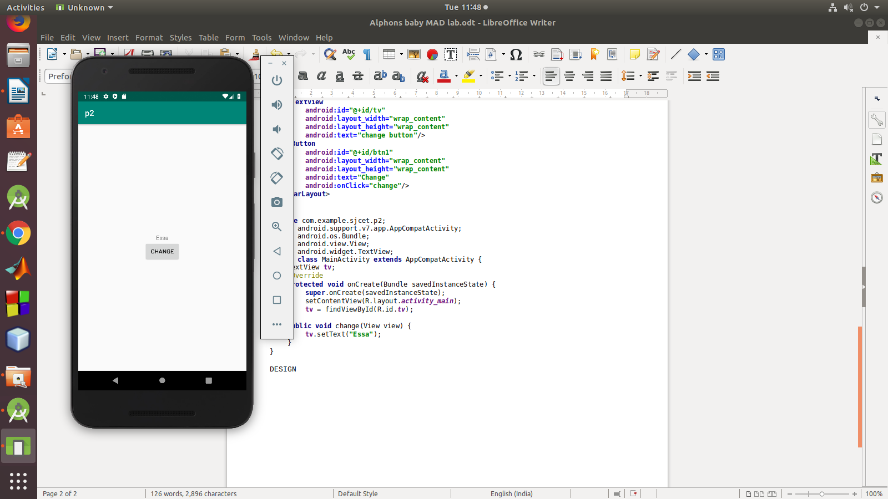DESIGN

3,READ A VALUE FROM EDIT TEXT AND PRINT IT IN A TEXT VIEW.

4,change the backgroud color on a button click

program

*<?***xml version="1.0" encoding="utf-8"***?>*

<**RelativeLayout**

**xmlns:android="http://schemas.android.com/apk/res/android"**

**xmlns:tools="http://schemas.android.com/tools"**

**android:id="@+id/rlVar1"**

**android:layout_width="match_parent"**

**android:layout_height="match_parent"**

**android:background="@color/green"**

**tools:context=".MainActivity"**>

<**TextView**

**android:id="@+id/tvVar1"**

**android:layout_width="wrap_content"**

**android:layout_height="wrap_content"**

**android:layout_centerHorizontal="true"**

**android:layout_marginTop="240dp"**

**android:text="What whould you like?"**

**android:textSize="30dp"**

**android:textStyle="bold"** />

<**LinearLayout**

**android:layout_width="wrap_content"**

**android:layout_height="wrap_content"**

**android:layout_below="@+id/tvVar1"**

**android:layout_centerInParent="true"**

**android:layout_marginTop="60dp"**

**android:orientation="horizontal"**

**android:padding="10dp"**>

<**Button**

**android:id="@+id/btVar1"**

**android:layout_width="150dp"**

**android:layout_height="wrap_content"**

**android:padding="20dp"**

**android:text="Cool"**

**android:textSize="25dp"** />

<**Button**

**android:id="@+id/btVar2"**

**android:layout_width="150dp"**

**android:layout_height="wrap_content"**

**android:padding="20dp"**

**android:text="Warm"**

**android:textSize="25dp"** />

</**LinearLayout**>

</**RelativeLayout**>

java

**package** com.example.sjcet.background;

**import** android.support.v7.app.AppCompatActivity;

**import** android.os.Bundle;

**import** android.view.View;

**import** android.widget.Button;

**import** android.widget.RelativeLayout;

**public class** MainActivity **extends** AppCompatActivity {

@Override

**protected void** onCreate(Bundle savedInstanceState) {

**super**.onCreate(savedInstanceState);

setContentView(R.layout.***activity_main***);

Button button1, button2;

**final** RelativeLayout relativeLayout;

button1 = findViewById(R.id.***btVar1***);

button2 = findViewById(R.id.***btVar2***);

relativeLayout = findViewById(R.id.***rlVar1***);

button1.setOnClickListener(**new** View.OnClickListener() {

@Override

**public void** onClick(View view) {

relativeLayout.setBackgroundResource(R.color.***cool***);

}

});

button2.setOnClickListener(**new** View.OnClickListener() {

@Override

**public void** onClick(View view) {

relativeLayout.setBackgroundResource(R.color.***warm***);

}

});

}

}

DESIGN

